Dear Parents and Pupils,
I am very excited to be joining Ilsington C of E Primary School as the new Year 2/3 class teacher. My name is Miss Willis and I am thrilled to be your new teacher. I’m looking forward to a year full of learning, fun, and adventures! I know that I am new and unfamiliar right now, but please don’t worry! We are going to have an awesome year together! I can’t wait to learn all about you, but first let me tell you a little bit about myself.
I was born and raised in Plymouth, and I am a middle child of FIVE! I have two older siblings, Donna and Martin, and two younger brothers, Aaron and Ciaran. I love them all very much! I also have two springer spaniels, Daisy and Alfie. I graduated from Marjon’s University in 2018 with a bachelor in Sports Coaching and Physical Education. I then completed my PGCE in Primary Education at Plymouth University in 2019. Although I am a newly qualified teacher, I have had lots of experience in schools across Devon.
I am very passionate about teaching all subjects, although P.E is my favourite. I absolutely love sports! When I was a child, I played many different sports, but football is my favourite. I often go and watch Plymouth Argyle play at Home Park. I can’t wait to share my passion for sports with you, so we can enjoy and explore sport activities together!
I think that it is very important to work together to create a family atmosphere in our class. We will be spending a lot of time together, so it is important to treat each other with respect, kindness and compassion. I know that each of you have different learning styles, which means you think and learn differently. It is my job as your teacher to help you grow as learners and as a person of good character.
When I am not teaching or planning exciting things for us to do at school, I enjoy playing sports, reading, baking, spending time with my family, and exploring Dartmoor with my friends! I love to go on walks and discover new places, so I can take lots of pictures. I also have a huge obsession with Disney! I love Disney films and have been known to break out into song on occasions. Maybe we can sing one together next year!
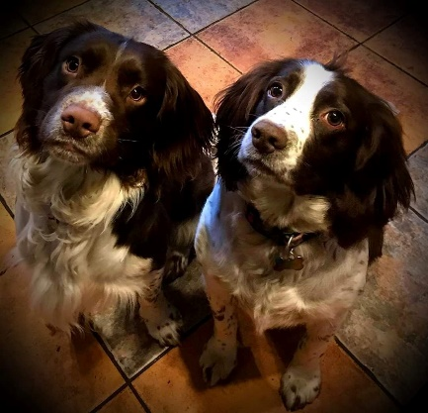
I can’t wait to meet you and your family in September! If you have any questions, please pass them onto your current teacher as I would be more than happy to answer them. During these uncertain times, I would like to assure you that I will endeavour to make the September transition a smooth and enjoyable one for the children. I am excited to join your school community and begin creating wonderful learning opportunities with your children.
A few of my favourite things
Favourite Colour: Purple
Favourite Season: Summer
Favourite Fruit: Watermelon
Favourite Restaurant: Wildwood
Favourite Animal: Elephant
Favourite Sport: Football
Favourite Book: Matilda
Favourite Vacation: Disney World Florida
Favourite Film: Anything Disney!!!

