Ilsington C of E Primary School
Ilsington, Newton Abbot, Devon, TQ13 9RE
Tel:01364 661208 Email: adminilsington@thelink.academy

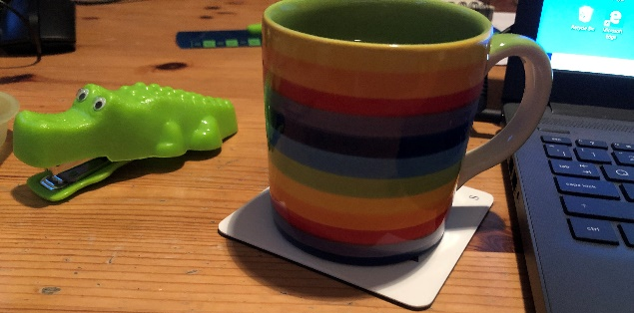
Notes from the attic

Dear Parents & Carers

As the tin foil is ripped excitedly off the next advent chocolate and you wonder where you put that pack of Christmas cards that you know, you had…somewhere, Christmas is beginning in school.
Christmas jumpers are making their appearance amongst the staff and we have invited the children to wear theirs every Friday for the next few weeks. There is even a rumour that there could be some Christmas elves in school on the last day of term. (Remember we will be leaving at 2pm on that day).

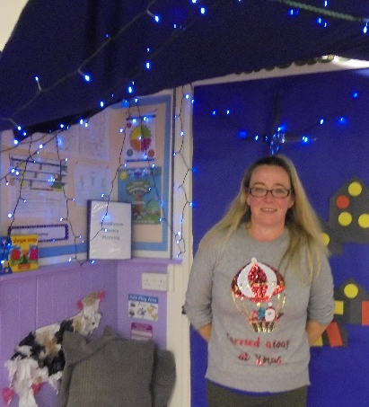
Today, I spent part of my lunch duty in pre-school. I was invited to sit on the straw bales and had to help tuck up the baby Jesus with his pet lizard, whilst looking out for the big bad wolf! You can see from the picture that Chris has created a lovely Nativity scene for the children to play in together and I love their idea that the three little pigs have moved in.

All of the children in year one and early years have opportunity to move through the continuous provision that has been set up by Chris, June and the early years team. I am sure that you will have chance to see pictures on Tapestry, the newsletter and on our website over the next few weeks too.

Meanwhile my office is filling up with all the fantastic gifts that our families have donated towards the Christmas appeal and I am trying hard not to approach the boxes of chocolates I can see sticking out of a bag nearby.

While we are organising some lovely opportunities for the children to sing Christmas songs and carols and to engage with the story of the Nativity , I’m afraid that we won’t be inviting you in to watch any performances this year. However, we very much hope to be able to provide you with opportunities to watch your children performing some Christmas songs.

I hope that you know we miss having you in school for Christmas Fayres and Nativity plays and that we would love to be able to invite you to a carol service or Christingle. But today, the government announced that the first vaccines are being rolled out to care homes and to the most vulnerable people. So there really is a light on the horizon!

You may have noticed a large container has suddenly appeared in the village hall car park, it is for the school, as we will be storing PE equipment in there during our move to the hall next term. We are gradually organising IT and resources ready for when we vacate the classrooms for the new build to begin. Thanks to the incredibly generous donations we have had for our appeal to fund some new laptops and IT equipment for the children we will have some lovely new laptops and software to support learning next term too.

With IT in mind, I need to remind you to check out the home learning resources your child’s teacher is posting onto Teams for you and your child to access each week. We have also sent out login reminders to help you to ensure that your child is able to access Timetables Rock Stars and Numbots. These are online resources which allow your child to access Maths resources designed to support their learning in a fun and engaging way.
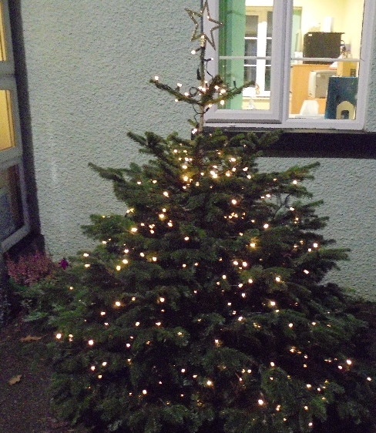

As a staff team we can’t wait for the day that we can open our doors to you all again and have some fun together. Until then, I hope that you can see that we are smiling behind our masks when you meet us on the gate and that you know that we will do everything we can, to make sure that your children have a lovely time over the next few weeks.

Take care, keep well and don’t forget that we are all here to help in any way that we can.

Kind regards

Sam McCarthy - Patmore

Academy Head.

