**English**

This term we will be looking at three different books:

**Fiction:** Augustus and His Smile

Using Pie Corbett Talk for writing skills, we will be adapting this book to create a story focusing on an animal losing something.

**Non-Fiction:** Creature features Dinosaurs

We will discuss different reptile and then create an information book based on a animal of our choice.

**Poetry:** Tell me a Dragon

We will imagine our own Dragon to create a Dragon book.

**Maths Y1**

Place Value within 10

Addition and Subtraction within 10

Geometry: Shape

Place Value within 20

**Maths Y2**

Place value

Addition and Subtraction

Measurement: Money

Multiplication and division

**PE – Thursday**

This term we will focus on fundamentals and gymnastics

**Outdoor Learning- Tuesday**

Children to come into school wearing appropriate clothes ready for outdoor learning.

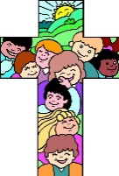****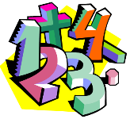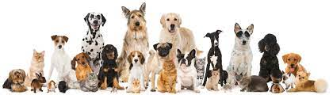

## **Carnival of the Animals Topic Web: Autumn Term**

## The children will explore the globe... finding out about animals that live in the African Savannah, the Australian outback, in cold places like the Arctic and Antarctic, as well as in our local neighborhood, pond life and farm animals.

## We will explore the colours and patterns of the African landscapes and native tribes. We will create African patterns, explore Maasai culture and their amazing homemade jewelry, make and decorate masks and water jars, admire the beautiful African sunset and so much more!

**Science**

**Animals including humans**

We will identify and name a variety of animals; take photographs and make sketches of animals we see. Plan an investigation to test what paper will be best to mop up a puppy’s accident. As well as observe different pets in school!

**Seasonal Changes**

We will discuss the four season and make seasonal collages together. Go outside and experience the wind and make windsock and windmills. Talk about the importance of the sun, design suncatchers and explore shadows using torches.

**\\**

**Computing**

Develop understanding of technology and how it can help us in everyday life. We will become familiar with the different components of a computer by developing their keyboard and mouse skills.

**PSHE**

Being me in this world

Celebrating Differences

**Home Learning**

**Reading**- please read with your child and sign their book log. Books will be changed every **Thursday.**

**Spellings**- spellings will go home every **Friday** to be tested the following **Thursday**.

**Number Bonds-** number bond sheets will go home every **Friday** to be tested the following **Thursday.**

**Music**

We will listen and appraise different genres of music, as well as learn to sing the songs and play different instruments.

**Religious Education**

This term we will learning about:

Who made the world?

What does it mean to belong to a faith community?