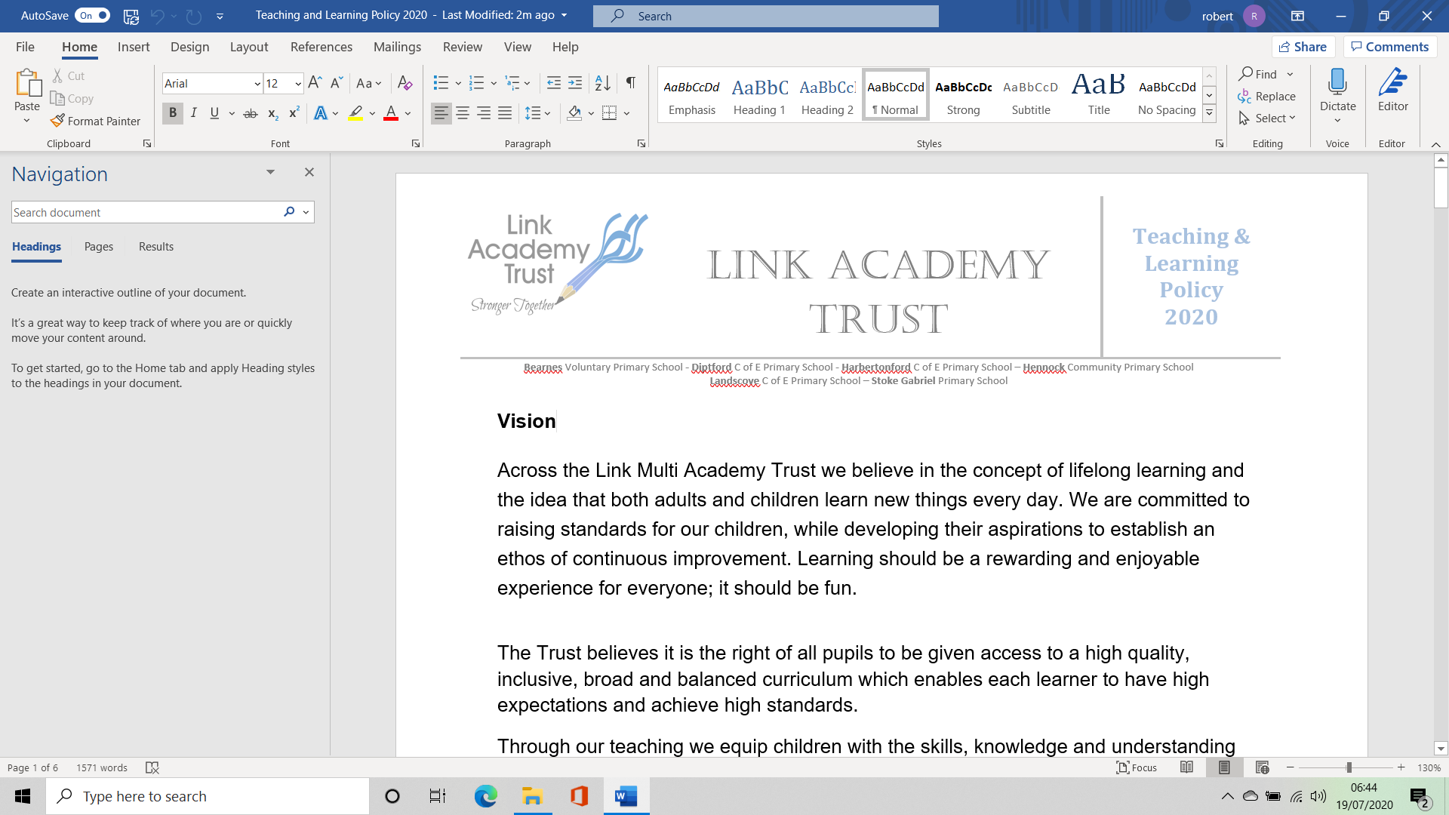

**Ilsington Academy Strategic Improvement Priorities**

**KEY IMPROVEMENT PRIORITIES for 2020-21**



**Key Priority 1**

**Quality of Education**

**Leadership & Management**

To improve progress data and increase the number of pupils achieving Greater Depth through greater consistency in all core subject areas of teaching.

**Key Priority 4**

**Quality of Education**

**Computing**

*To use IT to enhance excellent (cross curricular) teaching and learning and to develop online learning for an integrated, blended approach to enable a wider learning experience.*

**Key Priority 3**

**Quality of Education**

**EYFS**

To provide a learning environment that supports the teaching of an ambitious, creative, well sequenced curriculum that provides challenge for all EYFS children.

**Key Priority 2**

**Quality of Education**

**SEND**

To work with the Link’s inclusion hub to develop and improve systems and processes to support the needs of all children with SEND , providing quality first teaching for all.

**Key Priority 5**

***Personal Development***

***Behaviour & Attitudes***

***Social, Emotional Spiritual & Mental Health***

To embed a new SRE curriculum, making strong links with PSHE, RE and the school’s Christian and British values.

**Key Priority 6**

***Personal Development, Behaviour & Attitudes***

**SIAMS**

To be SIAMS ready; develop our Christian distinctiveness through renewed vision, mission statement and introducing the new Devon RE curriculum