Ilsington C of E Primary School
Ilsington, Newton Abbot, Devon, TQ13 9RE
Tel:01364 661208 Email: adminilsington@thelink.academy

2nd November 2020
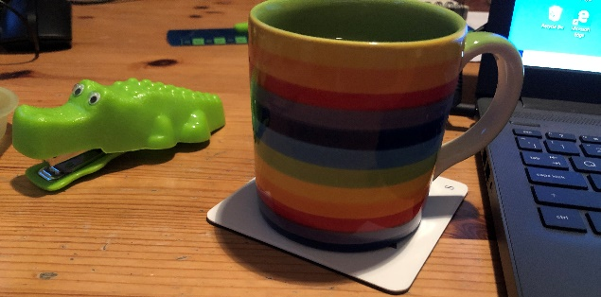
Notes from the attic

Dear Parents & Carers,

Hello again everyone, I hope that you have all had some fun with your children whilst they were off school and made the best of any sunny days.
As you will notice Honeywell’s gazebo didn’t make it through the windy conditions, however it was a fantastic resource while we were able to use it and I hope it can be used again next year. We have plans for providing more permanent structures to support outdoor learning in future which I will be able to share with you soon.
Meanwhile, the absence of the gazebo won’t mean that Honeywell will remain inside - all our children have waterproofs and wellies in school and so they will continue to learn outside at every opportunity. Meanwhile now that the children are settled and experienced in their use of class resources, we are able to move into allowing some shared provision. We will be opening up more areas of the Honeywell and Woodhouse classes to allow timetabled free flow for the children across all areas. This means for example that the older pre-school children will be able to benefit from phonics teaching and other activities with Mrs Barker. They will also have chance to share in the use of the mud kitchen and the construction in the Honeywell outdoor space, also benefiting from sharing some of the pre-school resources.

I was thinking of you all as I was watching Mr Johnson on the TV at the weekend and learnt about the weeks to come in lockdown. Many of you are probably missing the loved ones you are now unable to see. I was very upset over the holiday not to have been able to see my oldest son as he has a colleague who has Covid symptoms, so I have some idea of what you might be feeling. But this time the school is open - hurrah! So, whether you have to work from home or whether you are still going into work, you know that your children are happy and safe and will be having fun learning with us.
If you have any worries or queries please don’t hesitate to catch me on the gate or call or email the office, we are all here for you and we will do everything we can to make this time a positive one for the children.

Kind regards,
Sam McCarthy
Academy Head

