Ilsington C of E Primary School
Ilsington, Newton Abbot, Devon, TQ13 9RE
Tel:01364 661208 Email: adminilsington@thelink.academy

7/10/20
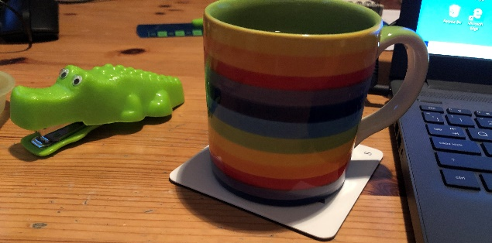
Notes from the attic

Dear Parents & Carers

I thought you might appreciate having a regular update whilst your access to the school site is so restricted. As a mum, I often wonder how I would feel in your shoes being unable to enter my child’s school. Although you have all adapted so brilliantly to the restrictions in place, the Ilsington team and I all really regret the distance between us at present. As I work in my attic office at home, I will try to put together something for you, to give you the inside picture of how we are working in the school.

At present, the teachers are working hard to upskill themselves with regard to their use of IT as we want to ensure that if there is a local lockdown that we will be able to provide children learning from home with more support than ever before.
As part of our drive to prepare for a future lockdown, we are looking to improve the ways that we can support home-learning and hope to offer a blend of paper based and IT based resources including videos of teachers presenting lessons.
At present we use videos, recorded Power points and Teams meetings to deliver collective worship across the school everyday with the vicar sharing a bible story via Youtube each week too. In case of lockdown we hope to be able to provide videos and recorded PowerPoints (with voiceover) to support learning each day and to provide more teacher presence in the home. It is possible that we will have teachers or pupils self -isolating or shielding in the weeks and months ahead and we really want to be prepared for that eventuality

At the same time, we have also been looking at the learning behaviours children need to enable them to work independently at home. As a school we are encouraging our children to be able to effectively organise their own learning and to have resilience and perseverance when meeting challenge. In Owlacombe children have been learning to work in a self organised learning environment designed to develop their own independent learning skills. We plan to develop the use of this approach across the school especially in the afternoons to help all of our children to develop these important skills. One of the effects of Covid restrictions has been to change the work place and to push forward our use of IT in a way that means many people are now working from home. Whether or not there is another lockdown locally, we believe we need to prepare our children for higher education and for the modern work place. Furthermore, the problems so many families faced in being able to support their children’s learning during lockdown could be alleviated if we can encourage a more confident, independent approach to learning moving forwards.
(I will post a Power Point on our school website for those of you who are interested in finding out more about the research behind this approach).

Health and hygiene has been on my mind a great deal this week as the weather has turned and the staff and children are having to consider how we ensure the children have suitable access to toilets and handwashing facilities without getting soaked in the rain . We are going to allow more time for use of handwashing at transition times through the day with bowls of hot soapy water in strategic places as many children left to their own devices aren’t cleaning their hands effectively. Please do check that your child has short clean nails as this really helps us.

As the Year 6 pupils are such a mature and well behaved group, we plan to give them more leadership opportunities in school this year and we will starting with using them as role models around the school at transition times such as on arrival in school and before break times. Over time, we will also be developing our school’s Ethos Team, Eco Team, School Council and more.

This week, teachers will be sending out Topic letters to you if they haven’t already. They are also working away in the background to get Microsoft Teams access set up for all children so that we can communicate between home and school more easily in future too.

Tomorrow I will be hosting the first parents focus group via Zoom giving parents the chance to talk about their aspiratios for the school for this academic year and start to think about Christina values. We will feedback to everyone and I look forward to having regular focus groups in the future giving plenty of opportunities for everyone to share their view and ideas.

I look forward to seeing you at pick up and drop off times this coming week. If I’m not on the gate because I’m teaching on Thursday morning or Friday- you know you can always call or drop the office a line and I’ll get back to you.

Keep safe, all the best

Sam McCarthy

Academy Head

