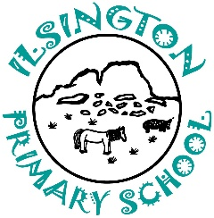
Ilsington C of E Primary School
Ilsington, Newton Abbot, Devon, TQ13 9RE
Tel:01364 661208 Email: adminilsington@thelink.academy

14/10/20
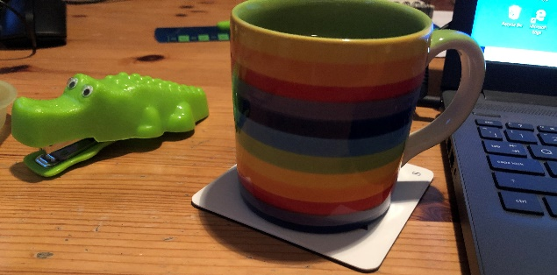
Notes from the attic

Dear Parents & Carers,

I hope that finds you all happy and well on this bright, crisp autumn day, despite the tales of gloom and doom we all hear every time we turn on a radio or TV. We seem to be relatively safe in regard to Covid in Devon at present. However, there are reports from other schools across the county of isolated cases in the locality. So, with that in mind, we are powering ahead with developing our ability to provide a blend of IT and paper-based resources for the children at Ilsington, known as ‘blended learning’. Our aim is to improve the support we were able to give you during lockdown earlier this year and to provide you with more teacher input at home.
This week we have used some pre-recorded sessions with classes and have also been able to practice recording live sessions using Teams too.
In class, the teachers are working to help children to understand how to access their class resources online via Teams. Ideally, they will become more able to work independently in the future, if working from home.

All the children, except those in Reception, now have access to Teams via an email address that has been provided for them. (We are still chasing emails for Foundation) and teachers are beginning to post resources and short tasks onto their class Teams pages.
Middlecott have been set a task which allows them to explore the use of Immersive Reader to support their reading of a text on Teams this week. Teachers are also experimenting with ways that they can provide online feedback to pupils to support the activities being set. It is going to take time to get everything set up here at school and to ensure that you at home can access what is set too - but I want you to know that we are making great strides in the right direction!

As the children are increasing their access to online learning, we have put together some guidance to support the children’s understanding of how to work well together online during virtual lessons. We have created a school Online Learning Agreement for the children for them to discuss in class and have also shared child friendly guides to cyber safety with them too. I will be sending copies home of both today for you to talk through with your children. The school office will be emailing you soon, asking you to confirm your support of the school’s approach to ensuring good online learning behavior and cyber safety.

Whilst considering all things Covid related I have been thinking about how we can further protect families and carers during pick up and drop off times. Thank you all so much, for putting up with the inconvenience of the staggered start and collection times each day and for the social distance you have all been keeping. I have heard that a number of schools are now asking that families wear masks when at the school gate and I thought I might ask you to consider doing this too. I know that we have people who have previously been shielding and of course there will be people with health and maternity issues amongst our families at the school gates so I’m putting this out as a suggestion.

With the beginning and end of the school day in mind could I please remind everyone who travels by car, to and from school, to please think really carefully about where you park. A number of parents have reported problems and upsets connected to this issue recently and I’m hoping that people might read this and perhaps allow themselves a little more time to find a safe place to park in future.

Parents evenings will sadly be another aspect of school life that will be affected by Covid restrictions. We will be contacting you soon to organise virtual meeting slots to allow you some face to face time with your child’s class teacher.

I also wanted to mention a point raised by a parent this week who, on reading Miss Willis’s class Topic letter, noticed that it said that we celebrate Maths and English. As a staff team we feel that it is important to communicate to you that we celebrate the whole range of a child’s emotional, spiritual and academic development throughout their time in school. We consistently look for positive ways to boost all children’s self esteem and to encourage them to be happy, creative, individuals.

Finally, can I just celebrate with you the 100% attendance children achieved at Ilsington last week, thank you all very much!

I look forward to seeing you on the gate as usual, where you will see me most days, unless I’m teaching. Don’t hesitate to contact me or the teaching team if you have any questions or queries. Enjoy the rest of the week and the weekend ahead.

Kind regards

Sam McCarthy

Academy Head.

