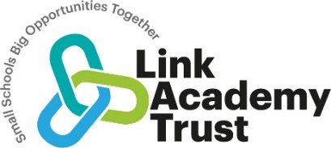
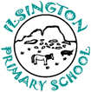
Ilsington CE Primary Science Curriculum Statement

Our Curriculum statements are designed to be used as a supportive tool to plan teaching and learning across our school.
The key skills are derived from the National Curriculum and spilt into individual year groups to support a progressive approach and mixed age classes.

We believe that Science permeates every aspect of our lives, from the technology we use on a daily basis to the natural world around us that sustains life on earth. Igniting children’s curiosity and passion to question and deepen their knowledge and understanding is central to our role as Science leaders. We believe that through Science, we can support the development of problem solving, critical thinking, evaluating and communicating that can be applied to the everyday challenges they face. We believe that igniting a passion in Science will give children the tools they need to discuss and debate global issues that will impact their lives and prepare them for a changing future.

We believe that our lessons should be rooted in exploration and development of ideas from one lesson to the next, so they can build on their previous learning creating a solid foundation of knowledge. We believe practical experiences should be meaningful and rigorous and lead children to question what they have done and where they should go next. We believe that Science should be inclusive and create experiences where everyone can take part.

We follow the National Curriculum and use the PLAN Science resources to support planning. https://www.planassessment.com/

Vocabulary

At Ilsington we understand that children’s command of vocabulary is fundamental to learning and progress across the curriculum. Vocabulary is developed actively, building systematically on pupil’s current knowledge and deepening their understanding of etymology and morphology (word origins and structures) to increase their store of words. Simultaneously, pupils make links between known and new vocabulary, and discuss and apply shades of meaning. In this way, children expand the vocabulary choices that are available to them. It is essential to introduce technical vocabulary which define each curriculum subject. Vocabulary development is underpinned by an oracy culture and a tiered approach. High value is placed on the conscious, purposeful selection of well-chosen vocabulary and appropriate sentence structure to enrich access to learning and feed into written work across the curriculum.

Our teachers use the PLAN Science resources to support planning the science curriculum and use the PLAN document Progression in Vocabulary to ensure that there is a stepped development in children’s use of vocabulary moving from pre-school up through the primary year, an example is shown below and the entire document is posted with this curriculum document on our website for easy access.

An example of the vocabulary progression statements used to support teaching and learning –
please see the PLAN document Progression in Vocabulary as posted on our website for full details.

Year Groups | Working Scientifically Vocabulary statements
Nursery & Reception | look closely, observe, watch, touch, feel, smell, listen, same, different, compare, ask questions, record, sort, group
Year 1&2 | observe, changes, patterns, grouping, sorting, compare, same, different, identify (name), measure, data, record results, drawing, picture, table, tally chart, present, pictogram, block chart, Venn diagram, ask questions, test, investigate, explore, equipment, resources, magnifying glass, hand lens, ruler, tape measure, metre stick, pipette, syringe, spoon, teaspoon, answer questions, interpret results, scientific enquiry, pattern seeking, comparative testing, observing over time, classifying, researching using secondary sources
Year 3&4 | practical work, fair testing, relationships, accurate, thermometer, data logger, stopwatch, timer, estimate, data, diagram, identification key, chart, bar chart, prediction, similarity, difference, evidence, information, findings, criteria, values, properties, characteristics, conclusion, explanation, reason, evaluate, improve
Year 5&6 | variables, independent variable, dependent variable, control variable, evidence, justify, argument (science), causal relationship, accuracy, precision, scatter graphs, bar graphs, line graphs, force meter
As a small school, with classes in curriculum phases, our curriculum is delivered as a two-year rolling program for mixed-year classes in each key stage. The blocks are carefully devised to teach a whole class together with appropriate differentiation while covering a whole key stage's worth of objectives over the course of two years. Our approach ensures that knowledge is developed through an enquiry approach and where appropriate, cross curricular links can be made.
Working scientifically is taught each lesson and through the knowledge objectives for that unit. This ensures that knowledge is developed through an enquiry approach and the two areas do not stand alone. As the children’s knowledge and understanding increases, they become more proficient in selecting, using scientific equipment, collating, and interpreting results, they become increasingly confident in their growing ability to come to conclusions based on real evidence. Pupils learn to use the five types of scientific enquiry, and these are incorporated over a year of teaching to ensure that children have the opportunity to: observe over time; pattern seek; identify, classify and group; carry out comparative and fair testing and research using secondary sources.
To support teachers in the delivery of the Science curriculum, the “Plan Assessment” resources are used provide a skeleton structure. Teachers use these to plan and deliver a unit of work that allows children to progress and build on prior learning. This resource supports teachers in driving pupil progress and helps learners a develop secure understanding of each key block of knowledge in order to progress to the next stage. We have avoided the use of set schemes of work as these often stifle creativity, both for the teachers and the children.
Our science planning is arranged to take advantage of seasonal study opportunities and to ensure progression in scientific working skills, while covering the National Curriculum for England. Generally, each year is comprised of 6 blocks of 6 sessions dedicated to one of the science areas, although sometimes we have opted for longer blocks, where two subjects are combined e.g seasonal change/ plants to ensure both coverage and pace are maintained. We have also combined subject across one time period when there are very few objectives on a particular subject. Whilst the plan is set out in timed blocks, if a set of objectives has been met with time to spare, the teacher may decide to move on to the next block as appropriate. Science is taught in two hour blocks each week to enable immersion, discussion and exploration ensuring that children have opportunity to build on previous knowledge. This weekly exposure to science allows for the progressive building of skills and knowledge and allows children to visit all sections of the plan, do review cycle of investigation.
A positive and encouraging classroom environment can be found across all Key Stages. Children’s questions are always welcomed, and they are given the opportunity to explore new ideas as well as test them. Curiosity is celebrated within the classroom and when we assess their prior knowledge, we also seek to record their questions and ideas for investigations. The progression and content of the rolling programmes have been planned to ensure children study a balance of science content each year, building on prior learning. We encourage reflection and pupil voice in our science planning and teaching and are developing a range of very practical, creative and engaging lessons which stimulate the children’s enthusiasm for science and encourage their interest in the subject. (See our website and Facebook pages for evidence of this approach).
Our school motto is Small school, big heart, big ideas, big picture and this is reflected in our approach to teaching and learning in science. The “big picture” references our need to look out into the wider world and the “big heart” refers to the kindness and compassion we show to others including to the animal kingdom and to the wider environment. Therefore, we aim to make our science lessons relevant to global issues to engage children with the global sustainability goals of food, water, climate, recycling and energy to be able to understand their impact on the planet and the implications for future generations, enabling them to take action. We seek opportunities to develop children’s scientific knowledge and awareness with science visits and visitors as well as valuing the experiences and expertise they bring to the lesson. We teach Science with inclusion in mind, using technology to support children with SEND with their communication. We also aim to use digital technology to provide children with creative, effective methods of recording their investigations and they are confident in using recorded PowerPoints and videos to this effect.
As a teaching team we will regularly review and reflect on our rolling program and will adjust it over time to ensure that it is as effective as possible.

Ilsington CE Primary School Science Rolling Programme:

This two year rolling programme, reflects the research carried out at the school into the need for coherence across the curriculum ( Gallimaufry to Coherence). The school continues to reflect on and develop its science curriculum and is currently focusing on how to ensure that 'substantive' knowledge, which is knowledge of the products of science, such as models, laws and theories and 'disciplinary knowledge', which is knowledge of the practices of science are secured within its curriculum to ensure that pupils’ scientific knowledge becomes established and “sticks”.
A revised version of this planning will be in place for the Spring term, drawing on the Plan resource, https://www.planassessment.com/
This continuously reflective process is an integral part of the school’s continuous drive for improvement.

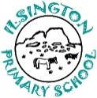
SCHOOL MIXED AGE TWO YEAR ROLLING PROGRAM FOR SCIENCE

KEY STAGE ONE HONEYWELL CLASS
Cycle A  Honeywell  Yrs 1&2  2021-2022 | Autumn 1 | Autumn 2 | Spring 1 | Spring 2 |  | Summer 1 | Summer 2
Cycle A  Honeywell  Yrs 1&2  2021-2022 | Yr 1&2 Living things in their habitats  Habitats and food chains  Biology |  | Yr 1 Animals including humans. (Parts of the body and animals)  Biology |  |  | Yr1 Plants  Identify and name common wild and gdn plants  Plant, observe and grow.  Yr2 Plants  Structure of plants, growing seeds/ bulbs outside; water/light  Biology
Cycle A & B Class SWAY Yr1 Seasonal change Plants Harvest/ cooking

Cycle B  Honeywell  Yrs 1&2  2022-23 | Yr1 Every day materials  Yr 2 Uses of everyday materials  Chemistry |  | Yr1 Plants  Identify and name common wild and gdn plants  Plant, observe and grow.  Yr2 Plants  Structure of plants, growing seeds/ bulbs outside; water/light  Biology |  |  | Y 2 Animals including humans  Identifying types , structure, herbivores, carnivores.  Biology
MIXED AGE TWO YEAR ROLLING PROGRAM FOR SCIENCE

LOWER KEY STAGE TWO MIDDLECOTT CLASS
 | Autumn 1 | Autumn 2 | Spring 1 | Spring 2 |  | Summer 1 | Summer 2
 | Yr 3 Plants (Gathering evidence of lifecycles)
Cycle A  Middlecott  Yrs 3&4  2021-2022 | Yr 3 Rocks  Chemistry  (Haytor) | Year 3 Forces and magnets  Physics | Y3 Plants (parts & their function & investigating growth)  Biology |  |  | Yr 3 Animals including humans  Food & Nutrition  Biology |  | Yr 4 Nutrition animals & humans)  Digestion & teeth  Biology
Cycle A & B Class SWAY Yr 4 Living things and their habitats (naming and identifying living things in the local environment) Growing plants
Cycle B  Middlecott  Yrs 3&4  2022-23 | Y4 Electricity  Physics (Diwali) | Yr 4 States of matter  Chemistry (Harvest cooking) |  | Yr 4 Living things and their habitats  Biology  (Seasonal) |  | Y3 Light  Physics  (Shadow-seasonal | Yr 4 Sound  Physics
MIXED AGE TWO YEAR ROLLING PROGRAM FOR SCIENCE

UPPER KEY STAGE TWO OWLACOMBE CLASS
 | Autumn 1 | Autumn 2 | Spring 1 | Spring 2 |  | Summer 1 | Summer 2
Cycle A  Owlacombe  Yrs 5&6  2021-22 | Yr 5 Properties and changes of materials. (Changes of materials)  Chemistry |  | Yr 6 Animals including humans  ( Circulation, drugs, diet, exercise, lifestyle)  Biology/ Chemistry |  | Yr5 Forces  (Gravity, air resistance, friction)  Physics  Yr 5 Earth & Space  Physics  (Space dome visit)
Cycle B  Owlacombe  Yrs 5&6  2022-23 | Yr 6 Living things in their habitats-Classification  Biology | Yr 6 Electricity  Physics | Year 6 Light  Physics | Yr 5 Living things in their habitats  ( Lifecycles, reproduction plants & animals ).  Biology  Seasonal | Yr 5 Animals including humans- Changes as humans develop.  Biology |  | Yr 6  Fossils, adaptation, inheritance, fossils, evolution  Biology  (RSE Link)

Working Scientifically at Ilsington CE Primary School
Working scientifically in EYFS:

In the EYFS, the characteristics of effective learning from the Statutory Framework for the Early Years Foundation Stage are the foundations on which the working scientifically skills build in Key Stage 1. While children are playing and exploring, teachers will be modelling, encouraging and supporting them to do the following:

show curiosity and ask questions
make observations using their senses and simple equipment
make direct comparisons
use equipment to measure
record their observations by drawing, taking photographs, using sorting rings or boxes and, in Reception, on simple tick sheets
use their observations to help them to answer their questions
talk about what they are doing and have found out
identify, sort and group.

In KS1/2 teachers use the working scientifically statements from the science National Curriculum for England to support their planning and ensure that these skills are developed over time, with reference to the PLAN materials ( See school website- Science planning).

Working scientifically in KS1/2 involves:

Making observations and taking measurements
Engaging in practical enquiry to answer questions
Recording and presenting evidence
Answering questions and concluding
Evaluating and raising further questions and predictions
Communicating their findings.

 | The National Curriculum
 | Key stage 1 programme of study - years 1 and 2  Working scientifically  During years 1 and 2, pupils should be taught to use the following practical scientific methods, processes and skills through the teaching of the programme of study content:  - asking simple questions and recognising that they can be answered in different ways  - observing closely, using simple equipment  - performing simple tests  - identifying and classifying  - using their observations and ideas to suggest answers to questions  - gathering and recording data to help in answering questions  Notes and guidance (non-statutory)  Pupils in years 1 and 2 should explore the world around them and raise their own questions. They should experience different types of scientific enquiries, including practical activities, and begin to recognise ways in which they might answer scientific questions.  They should use simple features to compare objects, materials and living things and, with help, decide how to sort and group them, observe changes over time, and, with guidance, they should begin to notice patterns and relationships.  They should ask people questions and use simple secondary sources to find answers.  They should use simple measurements and equipment (for example, hand lenses, egg timers) to gather data, carry out simple tests, record simple data, and talk about what they have found out and how they found it out. With help, they should record and communicate their findings in a range of ways and begin to use simple scientific language.  These opportunities for working scientifically should be provided across years 1 and 2 so that the expectations in the programme of study can be met by the end of year 2. Pupils are not expected to cover each aspect for every area of study.  Year 1 programme of study  Plants  Pupils should be taught to:  - identify and name a variety of common wild and garden plants, including deciduous and evergreen trees  - identify and describe the basic structure of a variety of common flowering plants, including trees  Notes and guidance (non-statutory)  Pupils should use the local environment throughout the year to explore and answer questions about plants growing in their habitat. Where possible, they should observe the growth of flowers and vegetables that they have planted.  They should become familiar with common names of flowers, examples of deciduous and evergreen trees, and plant structures (including leaves, flowers (blossom), petals, fruit, roots, bulb, seed, trunk, branches, stem). Pupils might work scientifically by: observing closely, perhaps using magnifying glasses, and comparing and contrasting familiar plants; describing how they were able to identify and group them, and drawing diagrams showing the parts of different plants including trees. Pupils might keep records of how plants have changed over time, for example, the leaves falling off trees and buds opening; and compare and contrast what they have found out about different plants.  Animals, including humans  Pupils should be taught to:  - identify and name a variety of common animals including fish, amphibians, reptiles, birds and mammals  - identify and name a variety of common animals that are carnivores, herbivores and omnivores  - describe and compare the structure of a variety of common animals (fish, amphibians, reptiles, birds and mammals including pets)  - identify, name, draw and label the basic parts of the human body and say which part of the body is associated with each sense  Notes and guidance (non-statutory)  Pupils should use the local environment throughout the year to explore and answer questions about animals in their habitat. They should understand how to take care of animals taken from their local environment and the need to return them safely after study. Pupils should become familiar with the common names of some fish, amphibians, reptiles, birds and mammals, including those that are kept as pets.  Pupils should have plenty of opportunities to learn the names of the main body parts (including head, neck, arms, elbows, legs, knees, face, ears, eyes, hair, mouth, teeth) through games, actions, songs and rhymes.  Pupils might work scientifically by: using their observations to compare and contrast animals at first hand or through videos and photographs, describing how they identify and group them; grouping animals according to what they eat; and using their senses to compare different textures, sounds and smells.  Everyday materials  Pupils should be taught to:  - distinguish between an object and the material from which it is made  - identify and name a variety of everyday materials, including wood, plastic, glass, metal, water, and rock  - describe the simple physical properties of a variety of everyday materials  - compare and group together a variety of everyday materials on the basis of their simple physical properties  Notes and guidance (non-statutory)  Pupils should explore, name, discuss and raise and answer questions about everyday materials so that they become familiar with the names of materials and properties such as: hard/soft; stretchy/stiff; shiny/dull; rough/smooth; bendy/not bendy; waterproof/not waterproof; absorbent/not absorbent; opaque/transparent. Pupils should explore and experiment with a wide variety of materials, not only those listed in the programme of study, but including for example: brick, paper, fabrics, elastic, foil.  Pupils might work scientifically by: performing simple tests to explore questions, for example: ‘What is the best material for an umbrella? … for lining a dog basket? … for curtains? … for a bookshelf? … for a gymnast’s leotard?’  Seasonal changes  Pupils should be taught to:  - observe changes across the 4 seasons  - observe and describe weather associated with the seasons and how day length varies  Notes and guidance (non-statutory)  Pupils should observe and talk about changes in the weather and the seasons.  Note: pupils should be warned that it is not safe to look directly at the sun, even when wearing dark glasses.  Pupils might work scientifically by: making tables and charts about the weather; and making displays of what happens in the world around them, including day length, as the seasons change.  Year 2 programme of study  Living things and their habitats  Pupils should be taught to:  - explore and compare the differences between things that are living, dead, and things that have never been alive  - identify that most living things live in habitats to which they are suited and describe how different habitats provide for the basic needs of different kinds of animals and plants, and how they depend on each other  - identify and name a variety of plants and animals in their habitats, including microhabitats  - describe how animals obtain their food from plants and other animals, using the idea of a simple food chain, and identify and name different sources of food  Notes and guidance (non-statutory)  Pupils should be introduced to the idea that all living things have certain characteristics that are essential for keeping them alive and healthy. They should raise and answer questions that help them to become familiar with the life processes that are common to all living things. Pupils should be introduced to the terms ‘habitat’ (a natural environment or home of a variety of plants and animals) and ‘microhabitat’ (a very small habitat, for example for woodlice under stones, logs or leaf litter). They should raise and answer questions about the local environment that help them to identify and study a variety of plants and animals within their habitat and observe how living things depend on each other, for example, plants serving as a source of food and shelter for animals. Pupils should compare animals in familiar habitats with animals found in less familiar habitats, for example, on the seashore, in woodland, in the ocean, in the rainforest.  Pupils might work scientifically by: sorting and classifying things according to whether they are living, dead or were never alive, and recording their findings using charts. They should describe how they decided where to place things, exploring questions like: ‘Is a flame alive? Is a deciduous tree dead in winter?’ and talk about ways of answering their questions. They could construct a simple food chain that includes humans (eg, grass, cow, human). They could describe the conditions in different habitats and microhabitats (under log, on stony path, under bushes); and find out how the conditions affect the number and type(s) of plants and animals that live there.  Plants  Pupils should be taught to:  - observe and describe how seeds and bulbs grow into mature plants  - find out and describe how plants need water, light and a suitable temperature to grow and stay healthy  Notes and guidance (non-statutory)  Pupils should use the local environment throughout the year to observe how plants grow. Pupils should be introduced to the requirements of plants for germination, growth and survival, as well as the processes of reproduction and growth in plants.  Note: seeds and bulbs need water to grow but most do not need light; seeds and bulbs have a store of food inside them.  Pupils might work scientifically by: observing and recording, with some accuracy, the growth of a variety of plants as they change over time from a seed or bulb, or observing similar plants at different stages of growth; setting up a comparative test to show that plants need light and water to stay healthy.  Animals, including humans  Pupils should be taught to:  - notice that animals, including humans, have offspring which grow into adults  - find out about and describe the basic needs of animals, including humans, for survival (water, food and air)  - describe the importance for humans of exercise, eating the right amounts of different types of food, and hygiene  Notes and guidance (non-statutory)  Pupils should be introduced to the basic needs of animals for survival, as well as the importance of exercise and nutrition for humans. They should also be introduced to the processes of reproduction and growth in animals. The focus at this stage should be on questions that help pupils to recognise growth; they should not be expected to understand how reproduction occurs.  The following examples might be used: egg, chick, chicken; egg, caterpillar, pupa, butterfly; spawn, tadpole, frog; lamb, sheep. Growing into adults can include reference to baby, toddler, child, teenager, adult.  Pupils might work scientifically by: observing, through video or first-hand observation and measurement, how different animals, including humans, grow; asking questions about what things animals need for survival and what humans need to stay healthy; and suggesting ways to find answers to their questions.  Uses of everyday materials  Pupils should be taught to:  - identify and compare the suitability of a variety of everyday materials, including wood, metal, plastic, glass, brick, rock, paper and cardboard for particular uses  - find out how the shapes of solid objects made from some materials can be changed by squashing, bending, twisting and stretching  Notes and guidance (non-statutory)  Pupils should identify and discuss the uses of different everyday materials so that they become familiar with how some materials are used for more than one thing (metal can be used for coins, cans, cars and table legs; wood can be used for matches, floors, and telegraph poles) or different materials are used for the same thing (spoons can be made from plastic, wood, metal, but not normally from glass). They should think about the properties of materials that make them suitable or unsuitable for particular purposes and they should be encouraged to think about unusual and creative uses for everyday materials. Pupils might find out about people who have developed useful new materials, for example John Dunlop, Charles Macintosh or John McAdam.  Pupils might work scientifically by: comparing the uses of everyday materials in and around the school with materials found in other places (at home, the journey to school, on visits, and in stories, rhymes and songs); observing closely, identifying and classifying the uses of different materials, and recording their observations. |  |  |  |  | Lower key stage 2 programme of study  Working scientifically  During years 3 and 4, pupils should be taught to use the following practical scientific methods, processes and skills through the teaching of the programme of study content:  - asking relevant questions and using different types of scientific enquiries to answer them  - setting up simple practical enquiries, comparative and fair tests  - making systematic and careful observations and, where appropriate, taking accurate measurements using standard units, using a range of equipment, including thermometers and data loggers  - gathering, recording, classifying and presenting data in a variety of ways to help in answering questions  - recording findings using simple scientific language, drawings, labelled diagrams, keys, bar charts, and tables  - reporting on findings from enquiries, including oral and written explanations, displays or presentations of results and conclusions  - using results to draw simple conclusions, make predictions for new values, suggest improvements and raise further questions  - identifying differences, similarities or changes related to simple scientific ideas and processes  - using straightforward scientific evidence to answer questions or to support their findings.  Notes and guidance (non-statutory)  Pupils in years 3 and 4 should be given a range of scientific experiences to enable them to raise their own questions about the world around them. They should start to make their own decisions about the most appropriate type of scientific enquiry they might use to answer questions; recognise when a simple fair test is necessary and help to decide how to set it up; talk about criteria for grouping, sorting and classifying; and use simple keys. They should begin to look for naturally occurring patterns and relationships and decide what data to collect to identify them. They should help to make decisions about what observations to make, how long to make them for and the type of simple equipment that might be used. They should learn how to use new equipment, such as data loggers, appropriately. They should collect data from their own observations and measurements, using notes, simple tables and standard units, and help to make decisions about how to record and analyse this data.  With help, pupils should look for changes, patterns, similarities and differences in their data in order to draw simple conclusions and answer questions. With support, they should identify new questions arising from the data, making predictions for new values within or beyond the data they have collected, and finding ways of improving what they have already done. They should also recognise when and how secondary sources might help them to answer questions that cannot be answered through practical investigations.  Pupils should use relevant scientific language to discuss their ideas and communicate their findings in ways that are appropriate for different audiences.  These opportunities for working scientifically should be provided across years 3 and 4 so that the expectations in the programme of study can be met by the end of year 4. Pupils are not expected to cover each aspect for every area of study.  Year 3 programme of study  Plants  Pupils should be taught to:  - identify and describe the functions of different parts of flowering plants: roots, stem/trunk, leaves and flowers  - explore the requirements of plants for life and growth (air, light, water, nutrients from soil, and room to grow) and how they vary from plant to plant  - investigate the way in which water is transported within plants  - explore the part that flowers play in the life cycle of flowering plants, including pollination, seed formation and seed dispersal  Notes and guidance (non-statutory)  Pupils should be introduced to the relationship between structure and function: the idea that every part has a job to do. They should explore questions that focus on the role of the roots and stem in nutrition and support, leaves for nutrition and flowers for reproduction.  Note: pupils can be introduced to the idea that plants can make their own food, but at this stage they do not need to understand how this happens.  Pupils might work scientifically by: comparing the effect of different factors on plant growth, for example, the amount of light, the amount of fertiliser; discovering how seeds are formed by observing the different stages of plant life cycles over a period of time; looking for patterns in the structure of fruits that relate to how the seeds are dispersed. They might observe how water is transported in plants, for example, by putting cut, white carnations into coloured water and observing how water travels up the stem to the flowers.  Animals, including humans  Pupils should be taught to:  - identify that animals, including humans, need the right types and amount of nutrition, and that they cannot make their own food; they get nutrition from what they eat  - identify that humans and some other animals have skeletons and muscles for support, protection and movement  Notes and guidance (non-statutory)  Pupils should continue to learn about the importance of nutrition and should be introduced to the main body parts associated with the skeleton and muscles, finding out how different parts of the body have special functions.  Pupils might work scientifically by: identifying and grouping animals with and without skeletons and observing and comparing their movement; exploring ideas about what would happen if humans did not have skeletons. They might compare and contrast the diets of different animals (including their pets) and decide ways of grouping them according to what they eat. They might research different food groups and how they keep us healthy, and design meals based on what they find out.  Rocks  Pupils should be taught to:  - compare and group together different kinds of rocks on the basis of their appearance and simple physical properties  - describe in simple terms how fossils are formed when things that have lived are trapped within rock  - recognise that soils are made from rocks and organic matter  Notes and guidance (non-statutory)  Linked with work in geography, pupils should explore different kinds of rocks and soils, including those in the local environment.  Pupils might work scientifically by: observing rocks, including those used in buildings and gravestones, and exploring how and why they might have changed over time; using a hand lens or microscope to help them to identify and classify rocks according to whether they have grains or crystals, and whether they have fossils in them. Pupils might research and discuss the different kinds of living things whose fossils are found in sedimentary rock and explore how fossils are formed. Pupils could explore different soils and identify similarities and differences between them and investigate what happens when rocks are rubbed together or what changes occur when they are in water. They can raise and answer questions about the way soils are formed.  Light  Pupils should be taught to:  - recognise that they need light in order to see things and that dark is the absence of light  - notice that light is reflected from surfaces  - recognise that light from the sun can be dangerous and that there are ways to protect their eyes  - recognise that shadows are formed when the light from a light source is blocked by an opaque object  - find patterns in the way that the size of shadows change  Notes and guidance (non-statutory)  Pupils should explore what happens when light reflects off a mirror or other reflective surfaces, including playing mirror games to help them to answer questions about how light behaves. They should think about why it is important to protect their eyes from bright lights. They should look for, and measure, shadows, and find out how they are formed and what might cause the shadows to change.  Note: pupils should be warned that it is not safe to look directly at the sun, even when wearing dark glasses.  Pupils might work scientifically by: looking for patterns in what happens to shadows when the light source moves or the distance between the light source and the object changes.  Forces and magnets  - compare how things move on different surfaces  - notice that some forces need contact between 2 objects, but magnetic forces can act at a distance  - observe how magnets attract or repel each other and attract some materials and not others  - compare and group together a variety of everyday materials on the basis of whether they are attracted to a magnet, and identify some magnetic materials  - describe magnets as having 2 poles  - predict whether 2 magnets will attract or repel each other, depending on which poles are facing  Notes and guidance (non-statutory)  Pupils should observe that magnetic forces can act without direct contact, unlike most forces, where direct contact is necessary (for example, opening a door, pushing a swing). They should explore the behaviour and everyday uses of different magnets (for example, bar, ring, button and horseshoe).  Pupils might work scientifically by: comparing how different things move and grouping them; raising questions and carrying out tests to find out how far things move on different surfaces, and gathering and recording data to find answers to their questions; exploring the strengths of different magnets and finding a fair way to compare them; sorting materials into those that are magnetic and those that are not; looking for patterns in the way that magnets behave in relation to each other and what might affect this, for example, the strength of the magnet or which pole faces another; identifying how these properties make magnets useful in everyday items and suggesting creative uses for different magnets.  Year 4 programme of study  Living things and their habitats  Pupils should be taught to:  - recognise that living things can be grouped in a variety of ways  - explore and use classification keys to help group, identify and name a variety of living things in their local and wider environment  - recognise that environments can change and that this can sometimes pose dangers to living things  Notes and guidance (non-statutory)  Pupils should use the local environment throughout the year to raise and answer questions that help them to identify and study plants and animals in their habitat. They should identify how the habitat changes throughout the year. Pupils should explore possible ways of grouping a wide selection of living things that include animals, flowering plants and non-flowering plants. Pupils could begin to put vertebrate animals into groups, for example: fish, amphibians, reptiles, birds, and mammals; and invertebrates into snails and slugs, worms, spiders, and insects.  Note: plants can be grouped into categories such as flowering plants (including grasses) and non-flowering plants, for example ferns and mosses.  Pupils should explore examples of human impact (both positive and negative) on environments, for example, the positive effects of nature reserves, ecologically planned parks, or garden ponds, and the negative effects of population and development, litter or deforestation.  Pupils might work scientifically by: using and making simple guides or keys to explore and identify local plants and animals; making a guide to local living things; raising and answering questions based on their observations of animals and what they have found out about other animals that they have researched.  Animals, including humans  Pupils should be taught to:  - describe the simple functions of the basic parts of the digestive system in humans  - identify the different types of teeth in humans and their simple functions  - construct and interpret a variety of food chains, identifying producers, predators and prey  Notes and guidance (non-statutory)  Pupils should be introduced to the main body parts associated with the digestive system, for example: mouth, tongue, teeth, oesophagus, stomach, and small and large intestine, and explore questions that help them to understand their special functions.  Pupils might work scientifically by: comparing the teeth of carnivores and herbivores and suggesting reasons for differences; finding out what damages teeth and how to look after them. They might draw and discuss their ideas about the digestive system and compare them with models or images.  States of matter  Pupils should be taught to:  - compare and group materials together, according to whether they are solids, liquids or gases  - observe that some materials change state when they are heated or cooled, and measure or research the temperature at which this happens in degrees Celsius (°C)  - identify the part played by evaporation and condensation in the water cycle and associate the rate of evaporation with temperature  Notes and guidance (non-statutory)  Pupils should explore a variety of everyday materials and develop simple descriptions of the states of matter (solids hold their shape; liquids form a pool not a pile; gases escape from an unsealed container). Pupils should observe water as a solid, a liquid and a gas and should note the changes to water when it is heated or cooled.  Note: teachers should avoid using materials where heating is associated with chemical change, for example, through baking or burning.  Pupils might work scientifically by: grouping and classifying a variety of different materials; exploring the effect of temperature on substances such as chocolate, butter, cream (for example, to make food such as chocolate crispy cakes and ice-cream for a party). They could research the temperature at which materials change state, for example, when iron melts or when oxygen condenses into a liquid. They might observe and record evaporation over a period of time, for example, a puddle in the playground or washing on a line, and investigate the effect of temperature on washing drying or snowmen melting.  Sound  Pupils should be taught to:  - identify how sounds are made, associating some of them with something vibrating  - recognise that vibrations from sounds travel through a medium to the ear  - find patterns between the pitch of a sound and features of the object that produced it  - find patterns between the volume of a sound and the strength of the vibrations that produced it  - recognise that sounds get fainter as the distance from the sound source increases  Notes and guidance (non-statutory)  Pupils should explore and identify the way sound is made through vibration in a range of different musical instruments from around the world; and find out how the pitch and volume of sounds can be changed in a variety of ways.  Pupils might work scientifically by: finding patterns in the sounds that are made by different objects such as saucepan lids of different sizes or elastic bands of different thicknesses. They might make earmuffs from a variety of different materials to investigate which provides the best insulation against sound. They could make and play their own instruments by using what they have found out about pitch and volume.  Electricity  Pupils should be taught to:  - identify common appliances that run on electricity  - construct a simple series electrical circuit, identifying and naming its basic parts, including cells, wires, bulbs, switches and buzzers  - identify whether or not a lamp will light in a simple series circuit, based on whether or not the lamp is part of a complete loop with a battery  - recognise that a switch opens and closes a circuit and associate this with whether or not a lamp lights in a simple series circuit  - recognise some common conductors and insulators, and associate metals with being good conductors  Notes and guidance (non-statutory)  Pupils should construct simple series circuits, trying different components, for example, bulbs, buzzers and motors, and including switches, and use their circuits to create simple devices. Pupils should draw the circuit as a pictorial representation, not necessarily using conventional circuit symbols at this stage; these will be introduced in year 6.  Note: pupils might use the terms current and voltage, but these should not be introduced or defined formally at this stage. Pupils should be taught about precautions for working safely with electricity.  Pupils might work scientifically by: observing patterns, for example, that bulbs get brighter if more cells are added, that metals tend to be conductors of electricity, and that some materials can and some cannot be used to connect across a gap in a circuit. |  |  |  | Upper key stage 2 programme of study  Working scientifically  During years 5 and 6, pupils should be taught to use the following practical scientific methods, processes and skills through the teaching of the programme of study content:  - planning different types of scientific enquiries to answer questions, including recognising and controlling variables where necessary  - taking measurements, using a range of scientific equipment, with increasing accuracy and precision, taking repeat readings when appropriate  - recording data and results of increasing complexity using scientific diagrams and labels, classification keys, tables, scatter graphs, bar and line graphs  - using test results to make predictions to set up further comparative and fair tests  - reporting and presenting findings from enquiries, including conclusions, causal relationships and explanations of and a degree of trust in results, in oral and written forms such as displays and other presentations  - identifying scientific evidence that has been used to support or refute ideas or arguments  Notes and guidance (non-statutory)  Pupils in years 5 and 6 should use their science experiences to: explore ideas and raise different kinds of questions; select and plan the most appropriate type of scientific enquiry to use to answer scientific questions; recognise when and how to set up comparative and fair tests and explain which variables need to be controlled and why. They should use and develop keys and other information records to identify, classify and describe living things and materials, and identify patterns that might be found in the natural environment.  They should make their own decisions about what observations to make, what measurements to use and how long to make them for, and whether to repeat them; choose the most appropriate equipment to make measurements and explain how to use it accurately. They should decide how to record data from a choice of familiar approaches; look for different causal relationships in their data and identify evidence that refutes or supports their ideas. They should use their results to identify when further tests and observations might be needed; recognise which secondary sources will be most useful to research their ideas and begin to separate opinion from fact.  They should use relevant scientific language and illustrations to discuss, communicate and justify their scientific ideas and should talk about how scientific ideas have developed over time.  These opportunities for working scientifically should be provided across years 5 and 6 so that the expectations in the programme of study can be met by the end of year 6. Pupils are not expected to cover each aspect for every area of study.  Year 5 programme of study  Living things and their habitats  Pupils should be taught to:  - describe the differences in the life cycles of a mammal, an amphibian, an insect and a bird  - describe the life process of reproduction in some plants and animals  Notes and guidance (non-statutory)  Pupils should study and raise questions about their local environment throughout the year. They should observe life-cycle changes in a variety of living things, for example, plants in the vegetable garden or flower border, and animals in the local environment. They should find out about the work of naturalists and animal behaviourists, for example, David Attenborough and Jane Goodall.  Pupils should find out about different types of reproduction, including sexual and asexual reproduction in plants, and sexual reproduction in animals.  Pupils might work scientifically by: observing and comparing the life cycles of plants and animals in their local environment with other plants and animals around the world (in the rainforest, in the oceans, in desert areas and in prehistoric times), asking pertinent questions and suggesting reasons for similarities and differences. They might try to grow new plants from different parts of the parent plant, for example, seeds, stem and root cuttings, tubers, bulbs. They might observe changes in an animal over a period of time (for example, by hatching and rearing chicks), comparing how different animals reproduce and grow.  Animals, including humans  Pupils should be taught to:  - describe the changes as humans develop to old age  Notes and guidance (non-statutory)  Pupils should draw a timeline to indicate stages in the growth and development of humans. They should learn about the changes experienced in puberty.  Pupils could work scientifically by researching the gestation periods of other animals and comparing them with humans; by finding out and recording the length and mass of a baby as it grows.  Properties and changes of materials  Pupils should be taught to:  - compare and group together everyday materials on the basis of their properties, including their hardness, solubility, transparency, conductivity (electrical and thermal), and response to magnets  - know that some materials will dissolve in liquid to form a solution, and describe how to recover a substance from a solution  - use knowledge of solids, liquids and gases to decide how mixtures might be separated, including through filtering, sieving and evaporating  - give reasons, based on evidence from comparative and fair tests, for the particular uses of everyday materials, including metals, wood and plastic  - demonstrate that dissolving, mixing and changes of state are reversible changes  - explain that some changes result in the formation of new materials, and that this kind of change is not usually reversible, including changes associated with burning and the action of acid on bicarbonate of soda  Notes and guidance (non-statutory)  Pupils should build a more systematic understanding of materials by exploring and comparing the properties of a broad range of materials, including relating these to what they learnt about magnetism in year 3 and about electricity in year 4. They should explore reversible changes, including evaporating, filtering, sieving, melting and dissolving, recognising that melting and dissolving are different processes. Pupils should explore changes that are difficult to reverse, for example, burning, rusting and other reactions, for example, vinegar with bicarbonate of soda. They should find out about how chemists create new materials, for example, Spencer Silver, who invented the glue for sticky notes or Ruth Benerito, who invented wrinkle-free cotton.  Note: pupils are not required to make quantitative measurements about conductivity and insulation at this stage. It is sufficient for them to observe that some conductors will produce a brighter bulb in a circuit than others and that some materials will feel hotter than others when a heat source is placed against them. Safety guidelines should be followed when burning materials.  Pupils might work scientifically by: carrying out tests to answer questions, for example, ‘Which materials would be the most effective for making a warm jacket, for wrapping ice cream to stop it melting, or for making blackout curtains?’ They might compare materials in order to make a switch in a circuit. They could observe and compare the changes that take place, for example, when burning different materials or baking bread or cakes. They might research and discuss how chemical changes have an impact on our lives, for example, cooking, and discuss the creative use of new materials such as polymers, super-sticky and super-thin materials.  Earth and space  Pupils should be taught to:  - describe the movement of the Earth and other planets relative to the sun in the solar system  - describe the movement of the moon relative to the Earth  - describe the sun, Earth and moon as approximately spherical bodies  - use the idea of the Earth’s rotation to explain day and night and the apparent movement of the sun across the sky  Notes and guidance (non-statutory)  Pupils should be introduced to a model of the sun and Earth that enables them to explain day and night. Pupils should learn that the sun is a star at the centre of our solar system and that it has 8 planets: Mercury, Venus, Earth, Mars, Jupiter, Saturn, Uranus and Neptune (Pluto was reclassified as a ‘dwarf planet’ in 2006). They should understand that a moon is a celestial body that orbits a planet (Earth has 1 moon; Jupiter has 4 large moons and numerous smaller ones).  Note: pupils should be warned that it is not safe to look directly at the sun, even when wearing dark glasses.  Pupils should find out about the way that ideas about the solar system have developed, understanding how the geocentric model of the solar system gave way to the heliocentric model by considering the work of scientists such as Ptolemy, Alhazen and Copernicus.  Pupils might work scientifically by: comparing the time of day at different places on the Earth through internet links and direct communication; creating simple models of the solar system; constructing simple shadow clocks and sundials, calibrated to show midday and the start and end of the school day; finding out why some people think that structures such as Stonehenge might have been used as astronomical clocks.  Forces  Pupils should be taught to:  - explain that unsupported objects fall towards the Earth because of the force of gravity acting between the Earth and the falling object  - identify the effects of air resistance, water resistance and friction, that act between moving surfaces  - recognise that some mechanisms including levers, pulleys and gears allow a smaller force to have a greater effect  Notes and guidance (non-statutory)  Pupils should explore falling objects and raise questions about the effects of air resistance. They should explore the effects of air resistance by observing how different objects such as parachutes and sycamore seeds fall. They should experience forces that make things begin to move, get faster or slow down. Pupils should explore the effects of friction on movement and find out how it slows or stops moving objects, for example, by observing the effects of a brake on a bicycle wheel. Pupils should explore the effects of levers, pulleys and simple machines on movement.  Pupils might find out how scientists, for example, Galileo Galilei and Isaac Newton helped to develop the theory of gravitation.  Pupils might work scientifically by: exploring falling paper cones or cupcake cases, and designing and making a variety of parachutes and carrying out fair tests to determine which designs are the most effective. They might explore resistance in water by making and testing boats of different shapes. They might design and make products that use levers, pulleys, gears and/or springs and explore their effects.  Year 6 programme of study  Living things and their habitats  Pupils should be taught to:  - describe how living things are classified into broad groups according to common observable characteristics and based on similarities and differences, including micro-organisms, plants and animals  - give reasons for classifying plants and animals based on specific characteristics  Notes and guidance (non-statutory)  Pupils should build on their learning about grouping living things in year 4 by looking at the classification system in more detail. They should be introduced to the idea that broad groupings, such as micro-organisms, plants and animals can be subdivided. Through direct observations where possible, they should classify animals into commonly found invertebrates (such as insects, spiders, snails, worms) and vertebrates (fish, amphibians, reptiles, birds and mammals). They should discuss reasons why living things are placed in one group and not another. Pupils might find out about the significance of the work of scientists such as Carl Linnaeus, a pioneer of classification.  Pupils might work scientifically by: using classification systems and keys to identify some animals and plants in the immediate environment. They could research unfamiliar animals and plants from a broad range of other habitats and decide where they belong in the classification system.  Animals including humans  Pupils should be taught to:  - identify and name the main parts of the human circulatory system, and describe the functions of the heart, blood vessels and blood  - recognise the impact of diet, exercise, drugs and lifestyle on the way their bodies function  - describe the ways in which nutrients and water are transported within animals, including humans  Notes and guidance (non-statutory)  Pupils should build on their learning from years 3 and 4 about the main body parts and internal organs (skeletal, muscular and digestive system) to explore and answer questions that help them to understand how the circulatory system enables the body to function.  Pupils should learn how to keep their bodies healthy and how their bodies might be damaged – including how some drugs and other substances can be harmful to the human body.  Pupils might work scientifically by: exploring the work of scientists and scientific research about the relationship between diet, exercise, drugs, lifestyle and health.  Evolution and inheritance  Pupils should be taught to:  - recognise that living things have changed over time and that fossils provide information about living things that inhabited the Earth millions of years ago  - recognise that living things produce offspring of the same kind, but normally offspring vary and are not identical to their parents  - identify how animals and plants are adapted to suit their environment in different ways and that adaptation may lead to evolution  Notes and guidance (non-statutory)  Building on what they learned about fossils in the topic on rocks in year 3, pupils should find out more about how living things on earth have changed over time. They should be introduced to the idea that characteristics are passed from parents to their offspring, for instance by considering different breeds of dogs, and what happens when, for example, labradors are crossed with poodles. They should also appreciate that variation in offspring over time can make animals more or less able to survive in particular environments, for example, by exploring how giraffes’ necks got longer, or the development of insulating fur on the arctic fox. Pupils might find out about the work of palaeontologists such as Mary Anning and about how Charles Darwin and Alfred Wallace developed their ideas on evolution.  Note: at this stage, pupils are not expected to understand how genes and chromosomes work.  Pupils might work scientifically by: observing and raising questions about local animals and how they are adapted to their environment; comparing how some living things are adapted to survive in extreme conditions, for example, cactuses, penguins and camels. They might analyse the advantages and disadvantages of specific adaptations, such as being on 2 feet rather than 4, having a long or a short beak, having gills or lungs, tendrils on climbing plants, brightly coloured and scented flowers.  Light  Pupils should be taught to:  - recognise that light appears to travel in straight lines  - use the idea that light travels in straight lines to explain that objects are seen because they give out or reflect light into the eye  - explain that we see things because light travels from light sources to our eyes or from light sources to objects and then to our eyes  - use the idea that light travels in straight lines to explain why shadows have the same shape as the objects that cast them  Notes and guidance (non-statutory)  Pupils should build on the work on light in year 3, exploring the way that light behaves, including light sources, reflection and shadows. They should talk about what happens and make predictions.  Pupils might work scientifically by: deciding where to place rear-view mirrors on cars; designing and making a periscope and using the idea that light appears to travel in straight lines to explain how it works. They might investigate the relationship between light sources, objects and shadows by using shadow puppets. They could extend their experience of light by looking a range of phenomena including rainbows, colours on soap bubbles, objects looking bent in water, and coloured filters (they do not need to explain why these phenomena occur).  Electricity  Pupils should be taught to:  - associate the brightness of a lamp or the volume of a buzzer with the number and voltage of cells used in the circuit  - compare and give reasons for variations in how components function, including the brightness of bulbs, the loudness of buzzers and the on/off position of switches  - use recognised symbols when representing a simple circuit in a diagram  Notes and guidance (non-statutory)  Building on their work in year 4, pupils should construct simple series circuits, to help them to answer questions about what happens when they try different components, for example, switches, bulbs, buzzers and motors. They should learn how to represent a simple circuit in a diagram using recognised symbols.  Note: pupils are expected to learn only about series circuits, not parallel circuits. Pupils should be taught to take the necessary precautions for working safely with electricity.  Pupils might work scientifically by: systematically identifying the effect of changing one component at a time in a circuit; designing and making a set of traffic lights, a burglar alarm or some other useful circuit.
 | Progression of skills to support questioning and planning.
 | 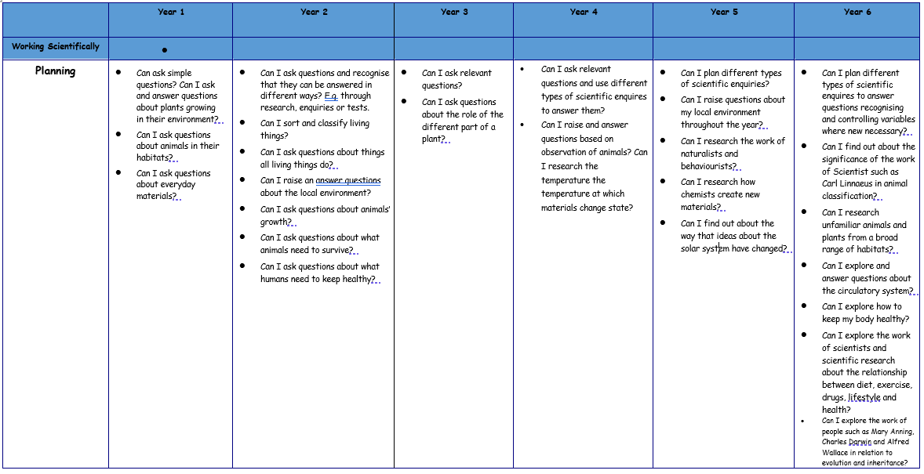

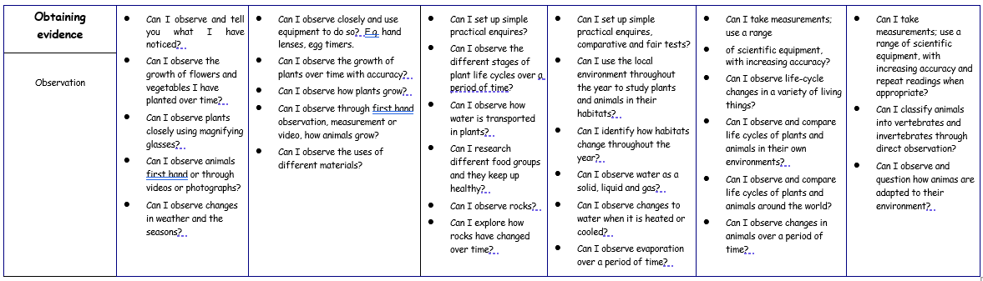

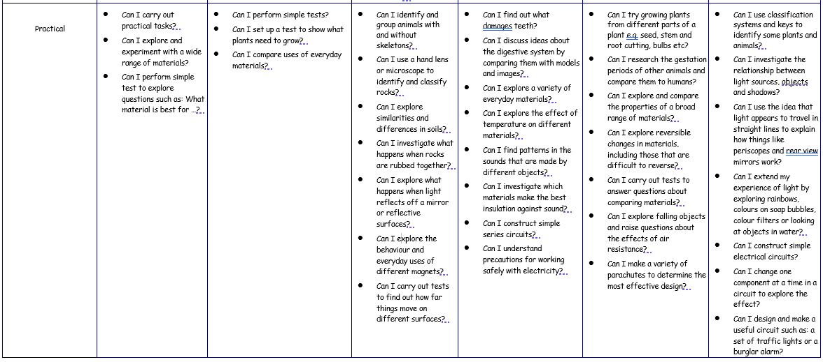

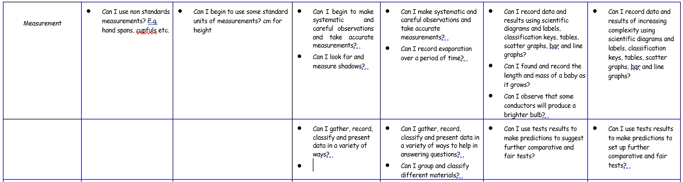

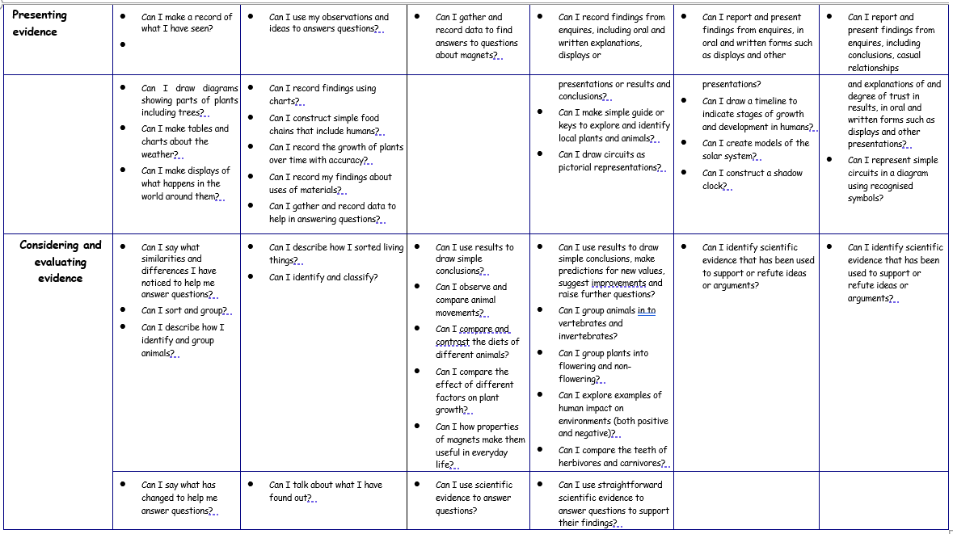

 | In order to assess impact - a guide
At the beginning of each unit an assessment of prior knowledge is carried out via an elicitation task. This may take the form of an assessment proforma, a discovery activity, a knowledge download page or a discussion with children talking about what they already know. In many cases, a combination of these methods is used. The scores from any proforma style tests are recorded on an Excel spreadsheet and managed by the class teacher. At the end of each unit of work, assessments are also recorded on the Science Lead’s assessment document to enable monitoring of progress against the objectives.

During each teaching unit, teachers use AFL to pick up on misconceptions that occur during the lesson. These are often addressed on the spot and explored through oracy or if marking is after the fact, a silent starter might be used at the start of the next lesson. Teachers also assess children’s working Scientifically skills during the lesson and look for areas that require further development. A final judgement for working scientifically is only made at the end of the year when children have had the opportunity to explore all aspects of the investigation cycle and had the opportunity to make these skills more substantive.

The progress of children with SEND who find writing and communication a barrier to completing a written assessment are assessed using a prior knowledge video and end of unit video recording where they have an opportunity to express and explain their knowledge and understanding. From this, the teacher is able to make a judgement of progress achieved from the beginning to the end of the unit. Where appropriate these children are given access to electronic devices to support verbal/ written communication.

There is an expectation that the learning in Science books will be the same quality as that in English books with regard to presentation. Marking of the Science books is at the same standard as marking of other writing across the curriculum. The focus for spelling corrections is on Science vocabulary words and the expectation is that children who are ARE will spell these correctly throughout their Science writing.

