Ilsington C of E Primary School
Ilsington, Newton Abbot, Devon, TQ13 9RE
Tel: 01364 661208 Email: adminilsington@thelink.academy

31st May 2020

Hello everyone,

I thought you might like a letter of your own so that you will have some idea of who your new head teacher will be in September. That’s me up there in the corner. I will be popping into school before September now and again but I know that I won’t see many of you until September, so I thought a letter might help.

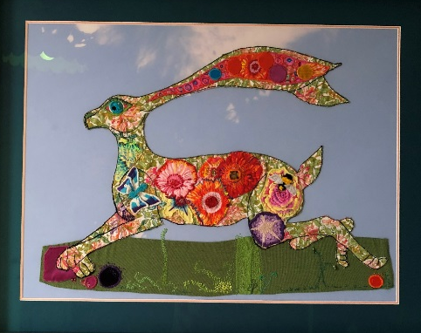
So, what can I tell you about myself…well, I love colour and I especially love rainbows, I even have a special rainbow umbrella which you’ll see on rainy days next term. In my spare time I enjoy drawing and sewing and I often use wildlife and hares in my artwork - this is a piece from last year called ‘Summer Hare’ which I really enjoyed making.

Teaching is one of the things I enjoy the most. When I come to join your school I will be teaching in all of the classes, some of the time and so I will be able to get to know everyone and you can help me to learn all of your names.

Although, I often teach in year six, I really do enjoy teaching all age groups and I especially enjoy reading stories and teaching writing.

(If you want to see me in my storytelling hat, you can find me on this link reading stories to children at Buckfastleigh Primary https://teach.classdojo.com/#/schools/56f4617c42203e960cade7de/story

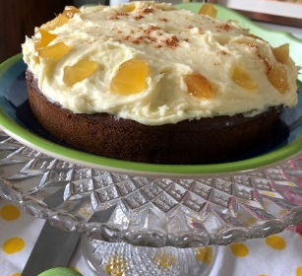
I live with my husband and as all of our children are grown-up now, only my daughter Melissa is left at home. She works with Nursery children and she is a fantastic cake maker - this is the ginger fudge cake that she makes for me sometimes as a special present. It is gorgeous but I have to do lots of walking or running or karate every time I eat a piece as its very sweet indeed!
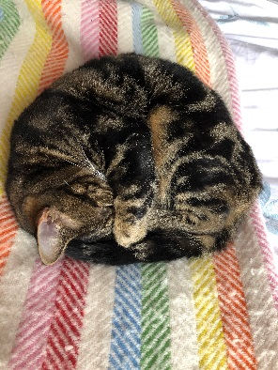

I also have three cats at home and one is an especially naughty little cat called Tallulah who has just drunk out of my glass of water as I was writing this letter- yuck!

So now perhaps you will feel that you know a little bit about me and I can’t wait to meet you all and to get to know you too.

If you would like to send me a picture or even a letter into school this summer, I will collect them from the school office and then I will be able to put them up in my new office when I join in September.

Keep smiling, be happy and I look forward to meeting you.

Best wishes

Mrs McCarthy

